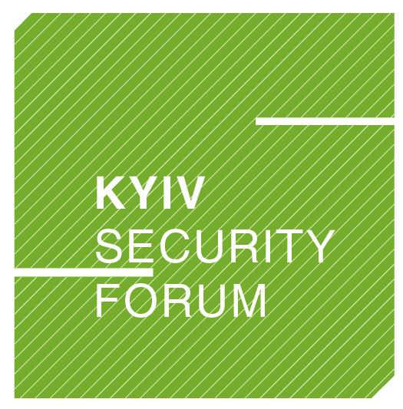

BLACK SEA SECURITY ROUNDTABLE
within the framework of Kyiv Security Forum
ODESA, MAY 25, 2011
(Hotel “Londonska”, 11 Prymorsky Blvr)
Black Sea Region:
a Geopolitical Puzzle or High-Priority Area?
11:30 – 12:30 | WELCOME COFFEE and REGISTRATION OF THE PARTICIPANTS (next to Grand Ballroom - Floor 1)
12:30 – 12:40 | GREETINGS FROM THE ORGANIZERS – Grand Ballroom (Floor 1)
Moderator: Dr. Mustafa AYDIN, Rector, Kadir Has University, Turkey

Opening remarks:
Ivanna KLYMPUSH-TSINTSADZE, Director, Open Ukraine Foundation
Dinu TODERASCU, Program Officer, Black Sea Trust for Regional Cooperation, Project of the German Marshall Fund of the United Stated
12:40 – 14:25 | PANEL I – Grand Ballroom (Floor 1)

Black Sea Security Dynamics
- Real and Imaginary Challenges of the Black Sea Security
- Depth of Transatlantic Strategic Engagement in the Wider Black Sea Region
- Russian-Turkish Rapprochement: Security Stabilizer or Irritant?
- The Consequences of Faltering the EU Interests for the Black Sea Security
Presentations:
H.E. Mr. Leonidas CHRYSANTHOPOULOS, Ambassador, Secretary General of the Permanent International Secretariat, BSEC
Dr. Dimitrios TRIANTAPHYLLOU, Director, Center for International and European Studies, Kadir Has University, Turkey
Dr. Pal DUNAY, Director, International Training Course in Security Policy, Geneva Centre for Security Policy, Switzerland
Iulian CHIFU, Director, Conflict Prevention and Early Warning Centre, Romania
14:25 – 14:55 | COFFEE BREAK - Small Ballroom – Floor 1
14:55 – 16:40 | PANEL II – Grand Ballroom (Floor 1)

Wider Black Sea Region Prospects – Are the Compromises Possible?
- The Future Role of the Smaller Stakeholders in the Black Sea Region in the Context of Shaping a Security Trialogue between the EU, Russia and Turkey
- The Prospects for Revitalization of Regional Initiatives in the Black Sea Region?
- How to Build Dialogue among Regional Actors to Promote Cooperation on Pressing Security Issues?
- Possible Compromises: Incentives/Enforcement and Their Application
Presentations:
Dr. Peter HAVLIK, Deputy Director, the Vienna Institute for International Economic Studies, Austria
Dr. Ognyan MINCHEV, Director, Institute for Regional and International Studies, Bulgaria
Panayotis GAVRAS, Head, Policy and Strategy, Black Sea Trade and Development Bank (BSTDB), Thessaloniki, Greece
H.E. Mr. Andriy VESELOVSKY, Ambassador at Large, Ministry of Foreign Affairs of Ukraine
16:40 – 17:10 | CONCLUDING REMARKS – Grand Ballroom (Floor 1)

Is Ukraine a “buffer zone” or active geopolitical player?
- What are the challenges for Ukraine as a neutral “Switzerland type” state in the European security system?
- Prospects of Ukraine becoming an active geopolitical player in the wider Black Sea region?
Presentations:
Mykola SUNHUROVSKYI, Director, Military Programs, Center of Economic and Political Research named after Razumkov, Ukraine
Vasyl IVASHKO, Counsellor, Department of Policy and Security, Ministry of Foreign Affairs of Ukraine
17:10 – 19:00 | RECEPTION (Small Ballroom – Floor 1)

Initiative and organization of:


With the support of: Media partner:

